CSC 555 Mining Big Data
Assignment 4
Due Monday, February 26th
- Consider a Hadoop job that will result in 79 blocks of output to HDFS.
Suppose that reading a block takes 1 minute and writing an output block to HDFS takes 1 minute. The HDFS replication factor is set to 2.

  - How long will it take for the reducer to write the job output on a 5-node Hadoop cluster? (ignoring the cost of Map processing, but counting replication cost in the output writing).

  - How long will it take for reducer(s) to write the job output to 10 Hadoop worker nodes? (Assume that data is distributed evenly and replication factor is set to 1)

  - How long will it take for reducer(s) to write the job output to 10 Hadoop worker nodes? (Assume that data is distributed evenly and replication factor is set to 2)

  - How long will it take for reducer(s) to write the job output to 100 Hadoop worker nodes? (Assume that data is distributed evenly and replication factor is set to 1)

  - Suppose that replication factor was changed to 3: how long will it take for the reducer to write the job output on a 5-node Hadoop cluster? (same question as a) but with replication of 3).

You can ignore the network transfer costs as well as the possibility of node failure.

  - Consider the following graph
X
Z

Y

Compute the page rank for the nodes in this graph. If you are multiplying matrices manually, you may stop after 6 steps. If you use a tool (e.g., Matlab, website, etc.) for matrix multiplication, you should get your answer to converge.

  - Now consider a dead-end node Q:
X
Z
Y
Q

What is the page rank of Q?

  - Exercise 5.1.6 from Mining of Massive Datasets
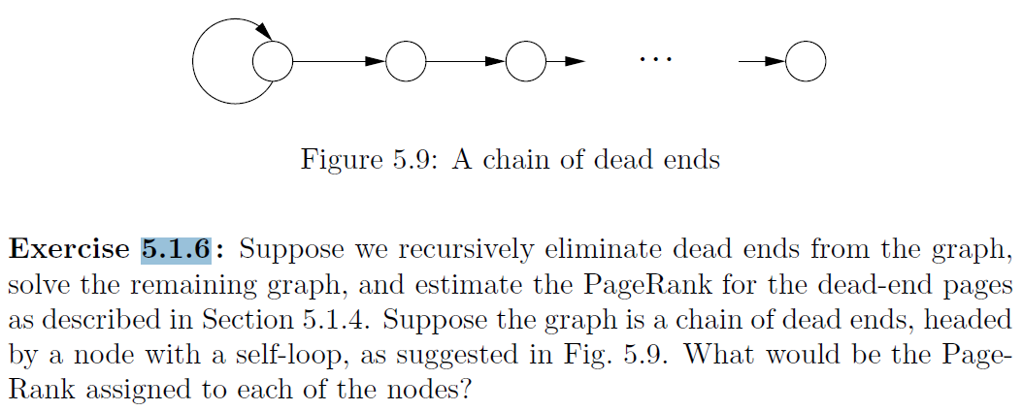

- Given the input data [(1pm, $5), (2pm, $15), (3pm, $15), (4pm, $20), (5pm, $10), (6pm, $20), (7pm, $30), (8pm, $25), (9pm, $22), (10pm, $30), (11pm, $30), (12pm, $40)]. We will discuss Storm on Wednesday.

  - What will the Hive query “compute average price” return? (yes, this is as obvious as it seems, asked for comparison with part-b)

  - What will a Storm query “compute average price per each 4 hour window” return? (tumbling, i.e., non-overlapping window of tuples, as many as you can fit)

  - What will a Storm query “compute average price per each 4 hour window” return? (sliding, i.e. overlapping window of tuples, moving the window forward 3 hours each time)

- In this section you will run another custom MapReduce job. You can either use Hadoop streaming or a Java implementation if you prefer.

Implement and run MapReduce to compute: Count number of distinct odd integers in the input file – e.g., {1,2,3,1,5,2,3, 4, 4, 1} => should give you a count of 3 because 1, 3, and 5 are present at least once).
You can generate the input file using this python code linked below (it will create a data file NumbersAndStrings.txt, run with python numStrings.py), it will take about a minute or so. Note that the text file contains numbers and non-numeric data. Your mapper will have to skip over elements that are not numbers.

http://rasinsrv07.cstcis.cti.depaul.edu/CSC555/numStrings.py

Don’t forget to submit the code you used, the output and screenshot of Hadoop streaming running.

- In this section you will practice using HBase and setup Mahout and run the curve-clustering example that we discuss in class on 2/21.

  - Note that HBase runs on top of HDFS, bypassing MapReduce (so only NameNode and DataNode need to be running). You can use your 3-node cluster or the 1-node cluster to run HBase, but specify which one you used.

cd
(Download HBase)
wget http://rasinsrv07.cstcis.cti.depaul.edu/CSC555/hbase-0.90.3.tar.gz
gunzip hbase-0.90.3.tar.gz
tar xvf hbase-0.90.3.tar

cd hbase-0.90.3

(Start HBase service, there is a corresponding stop service and this assumes Hadoop home is set)
bin/start-hbase.sh
(Open the HBase shell – at this point jps should show HMaster)
bin/hbase shell

(Create an employee table and two column families – private and public. Please watch the quotes, if ' turns into ‘, the commands will not work)
create 'employees', {NAME=> 'private'}, {NAME=> 'public'}
put 'employees', 'ID1', 'private:ssn', '111-222-334'
put 'employees', 'ID2', 'private:ssn', '222-333-445'
put 'employees', 'ID3', 'private:address', '123 Fake St.'
put 'employees', 'ID1', 'private:address', '243 N. Wabash Av.'

scan 'employees'

Now that we have filled in a few values, add at least 2 columns with at least 5 new values total to the “public” column family (e.g., position, officeNumber). Verify that the table has been filled in properly with scan command and submit a screenshot.

  - Download and setup Mahout:

cd
(download mahout zip package)
wget http://rasinsrv07.cstcis.cti.depaul.edu/CSC555/apache-mahout-distribution-0.11.2.zip
(Unzip the file)
unzip apache-mahout-distribution-0.11.2.zip

set the environment variables (as always, you can put these commands in ~/.bashrc to automatically set these variables every time you open a new connection, source ~/.bashrc to refresh)
export MAHOUT_HOME=/home/ec2-user/apache-mahout-distribution-0.11.2
export PATH=/home/ec2-user/apache-mahout-distribution-0.11.2/bin:$PATH
be absolutely sure you set Hadoop home variable (if you haven’t):

Download and prepare synthetic data – it represents a list of 2D curves, represented as a 50-point vector.

Download the synthetic data example:
wget http://rasinsrv07.cstcis.cti.depaul.edu/CSC555/synthetic_control.data
(make a testdata directory in HDFS, the example KMeans algorithm assumes the data lives there by default.
hadoop fs -mkdir -p testdata
(copy the synthetic data over to the testdata directory on HDFS side. You can inspect the contents of the file by running nano synthetic_control.data – as you can see this is a list of 600 vectors, with individual values separated by a space)
hadoop fs -put synthetic_control.data testdata/

Please be sure to report the runtime of any command that includes “time”
time mahout org.apache.mahout.clustering.syntheticcontrol.kmeans.Job

(clusterdump is a built-in Mahout command that will produce the result of KMeans. Output file is written to clusters-10-final because that is where the output is written after 10 iterations. The center points are placed in a separate file, called clusteredPoints)
mahout clusterdump --input output/clusters-10-final --pointsDir output/clusteredPoints --output clusteranalyze.txt

The file clusteranalyze.txt contains the results of the Kmeans run after 10 iterations.

Submit the screenshot of the first page from clusteranalyze.txt (e.g., from more clusteranalyze.txt)

Submit a single document containing your written answers. Be sure that this document contains your name and “CSC 555 Assignment 4” at the top.

